Apply filters to SQL queries

Project description
The project is about an investigation I have done on a login attempt attack data of a company. The log in attempts table keeps the login attempts time, date, offices and their locations. The login attempts were successful or not are marked as 0 and 1 , 0 describes as failed and 1 describes as successful attempts.

Retrieve after hours failed login attempts
I noticed some activity on the login attempts table. I noticed the activities occurred after 18:00. So, I queried the login attempts table by using where conditions to show me logins after 18:00. Total attempts after that time were 19 and they were Failed attempts.
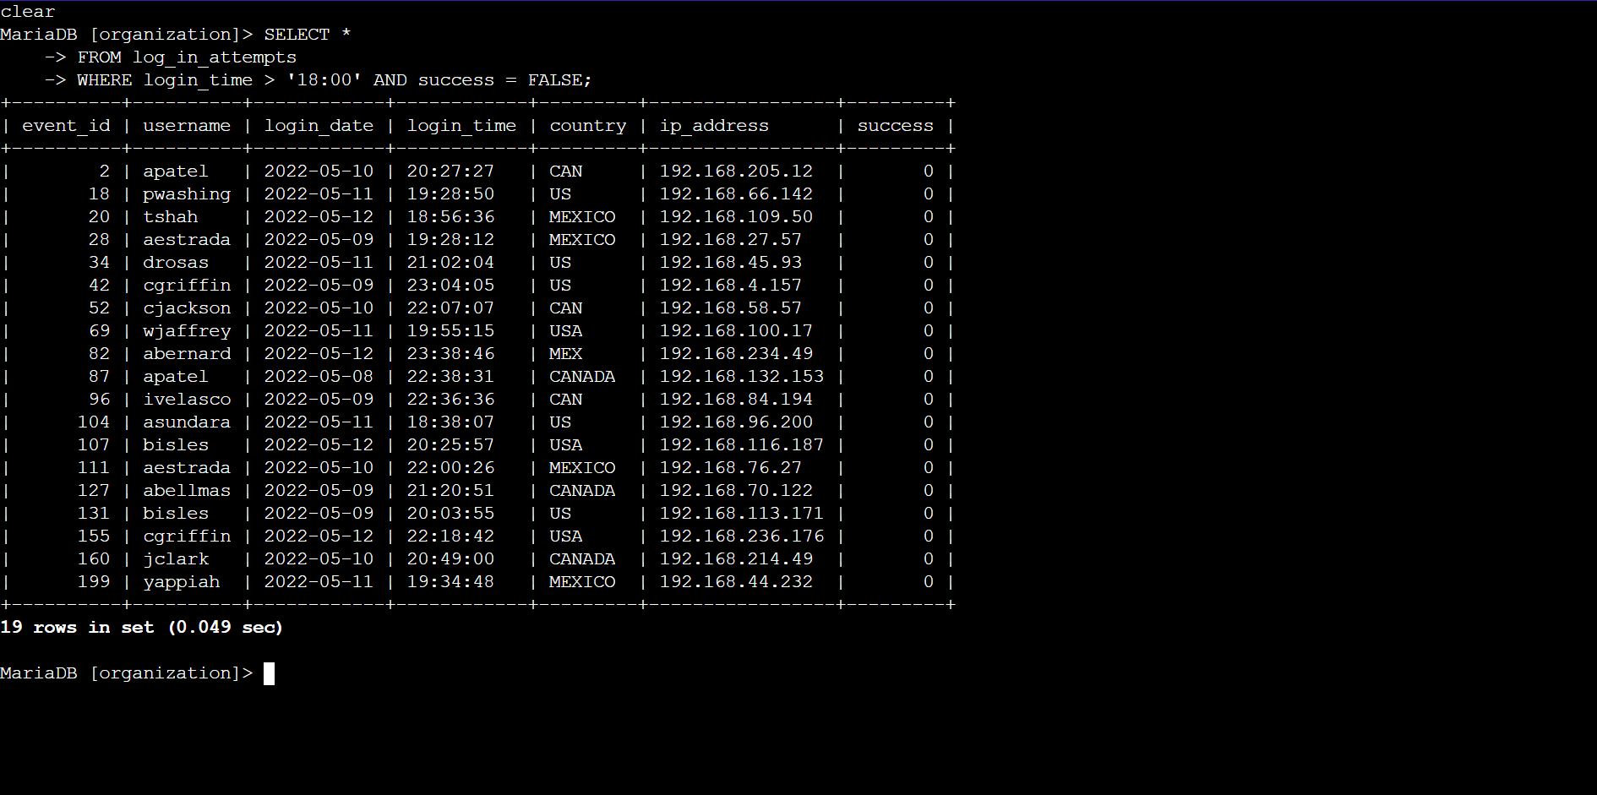

Retrieve login attempts on specific dates
Here I retrieved the login attempts based on specific dates from to narrow down the specific suspicious activities 2022-05-09 or 2022-05-08. Here, I saw some successful login attempts went thought. Total number to logins on these dates were 75.
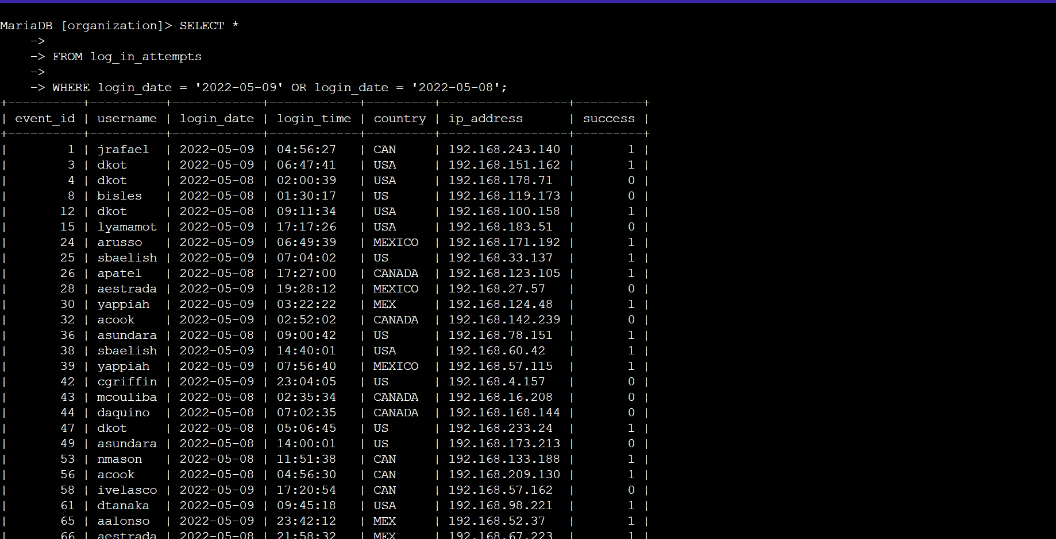

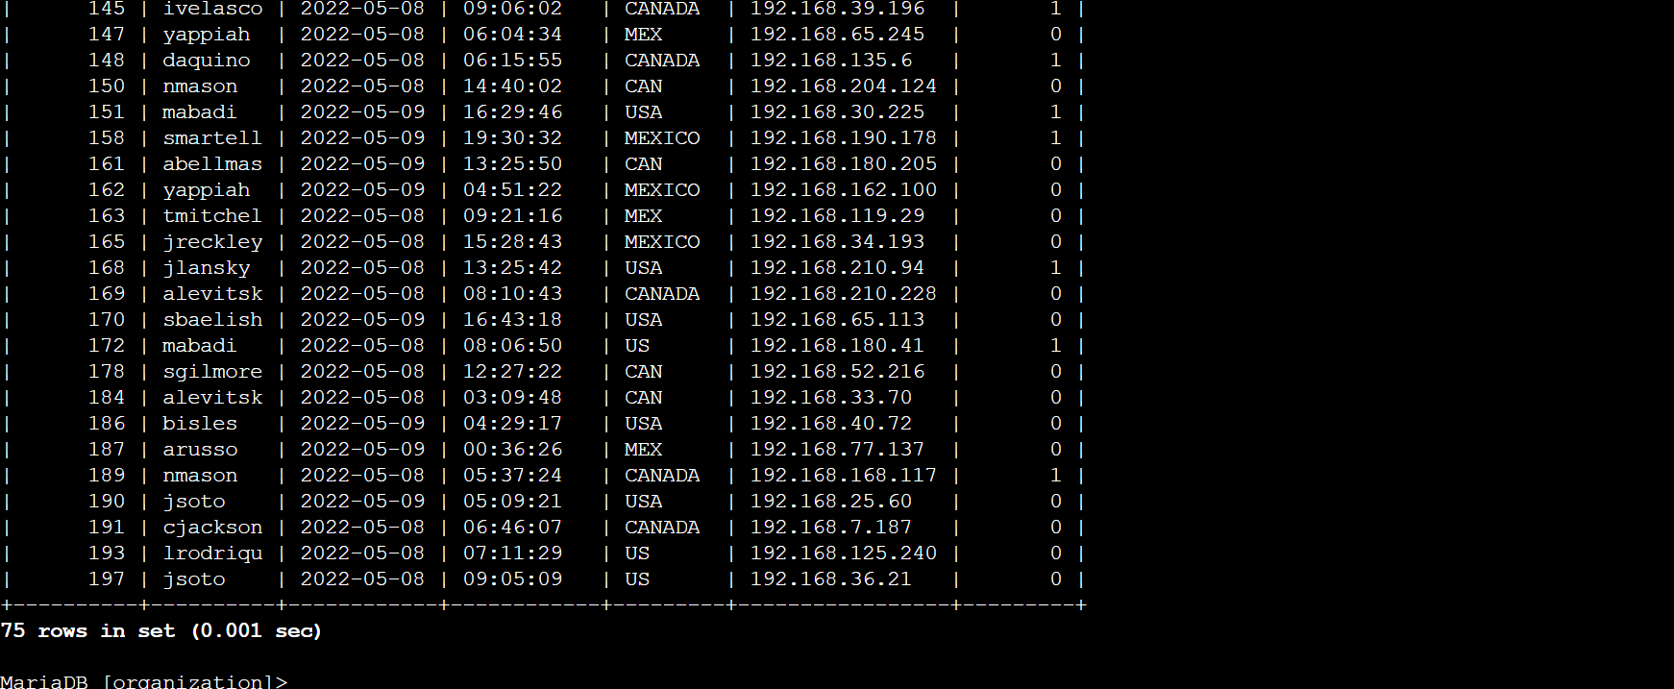

Retrieve login attempts outside of Mexico
After some looking around, I saw that the suspicious activities within the login attempts were not originated from Mexico region. Now I filtered out the data base using NOT and where conditions to show all attempts that did not had Mex or Mexico word in the country column using % operator. Total number of login attempts outside of Mexico region were 144.
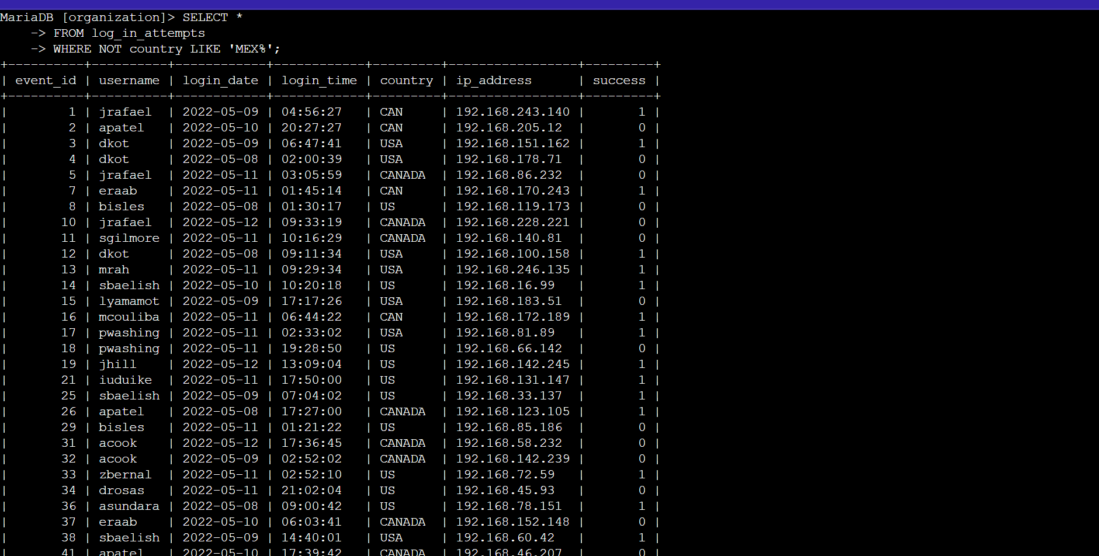

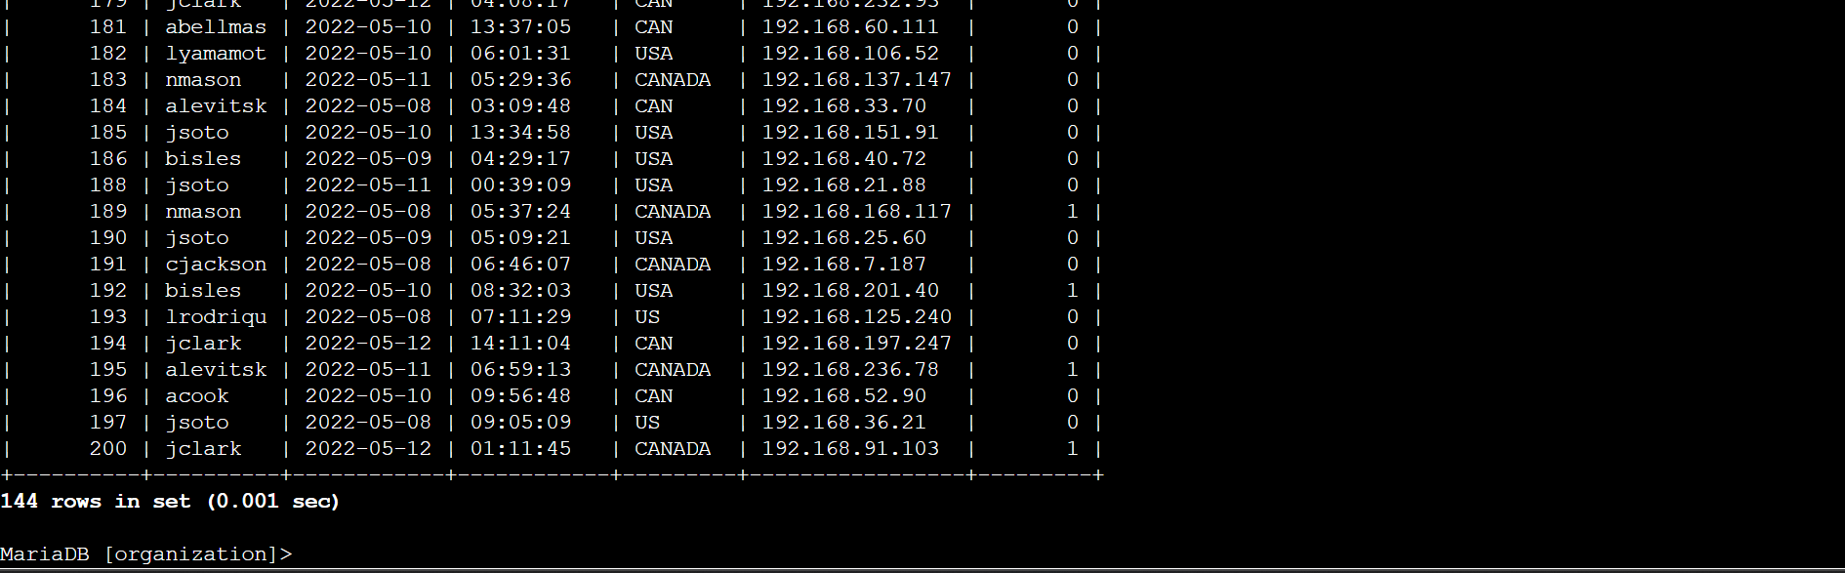

Retrieve employees in Marketing
To do this I used % operator and LIKE keyword along with Where condition to query all the employees of marketing department from employees table of the East building.
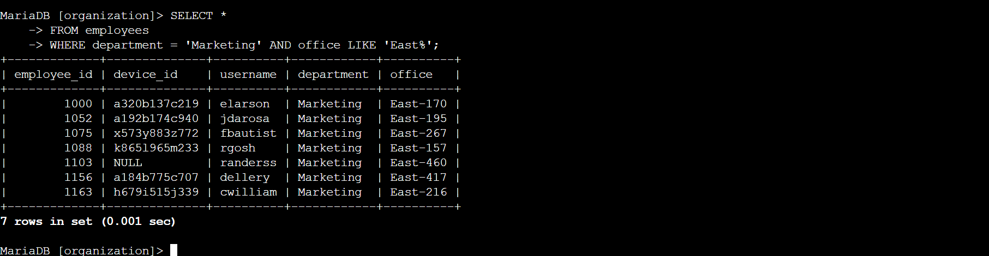

Retrieve employees in Finance or Sales
To do this I used AND keyword and Where condition to filter out the database to show all the employees of Finance and Sales department.
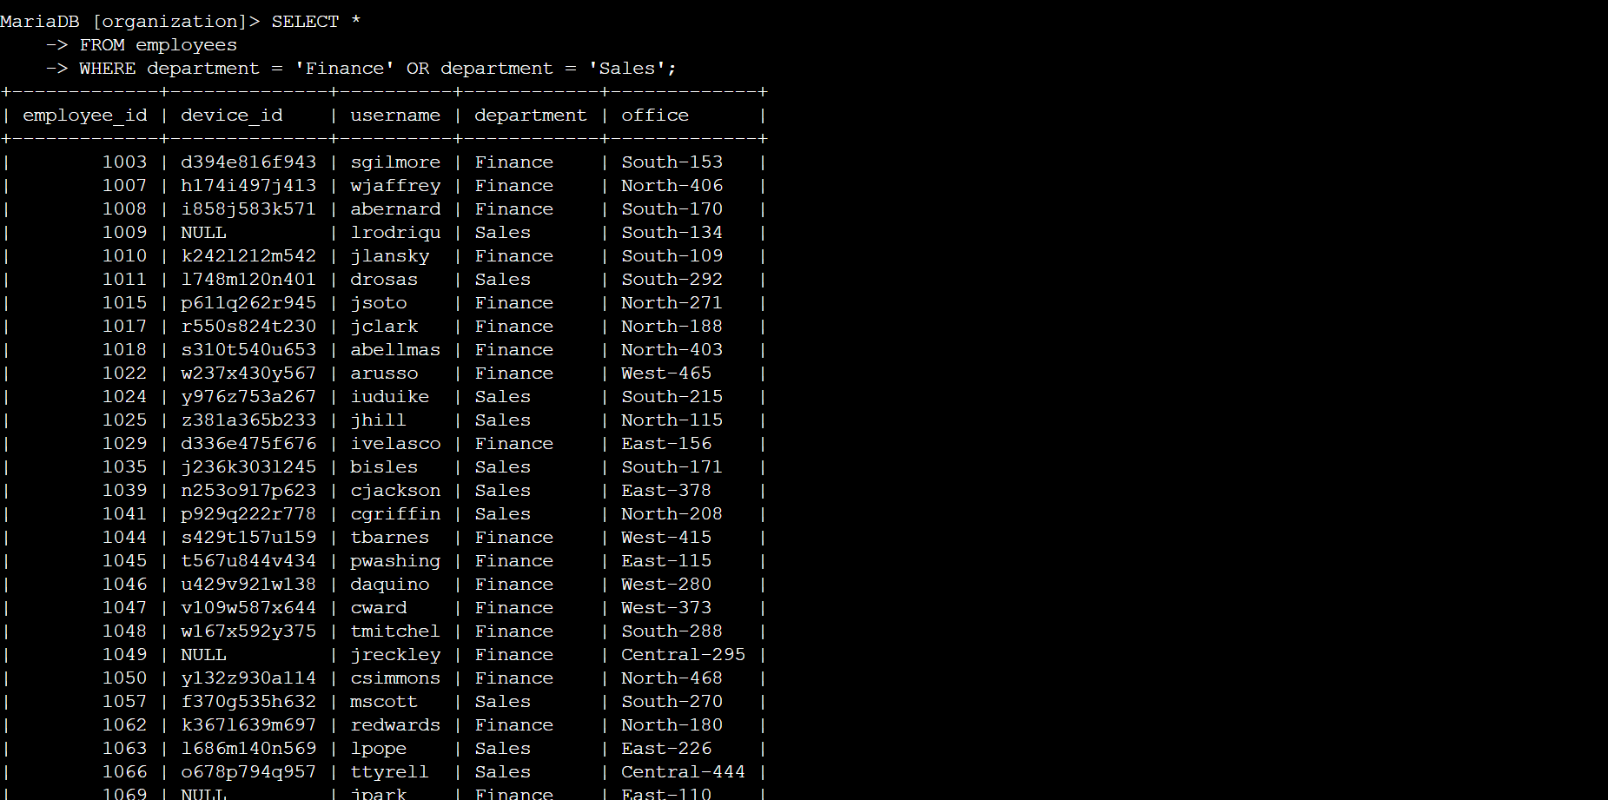

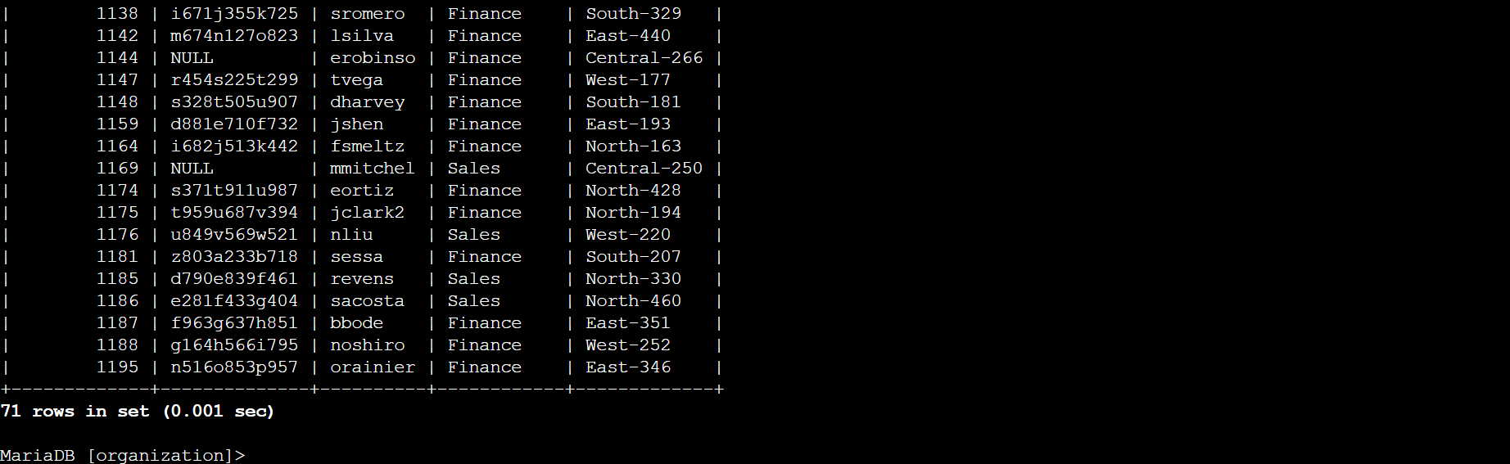

Retrieve all employees not in IT
To do this I used NOT keyword along with where to filter out the employees who are not in the IT department.
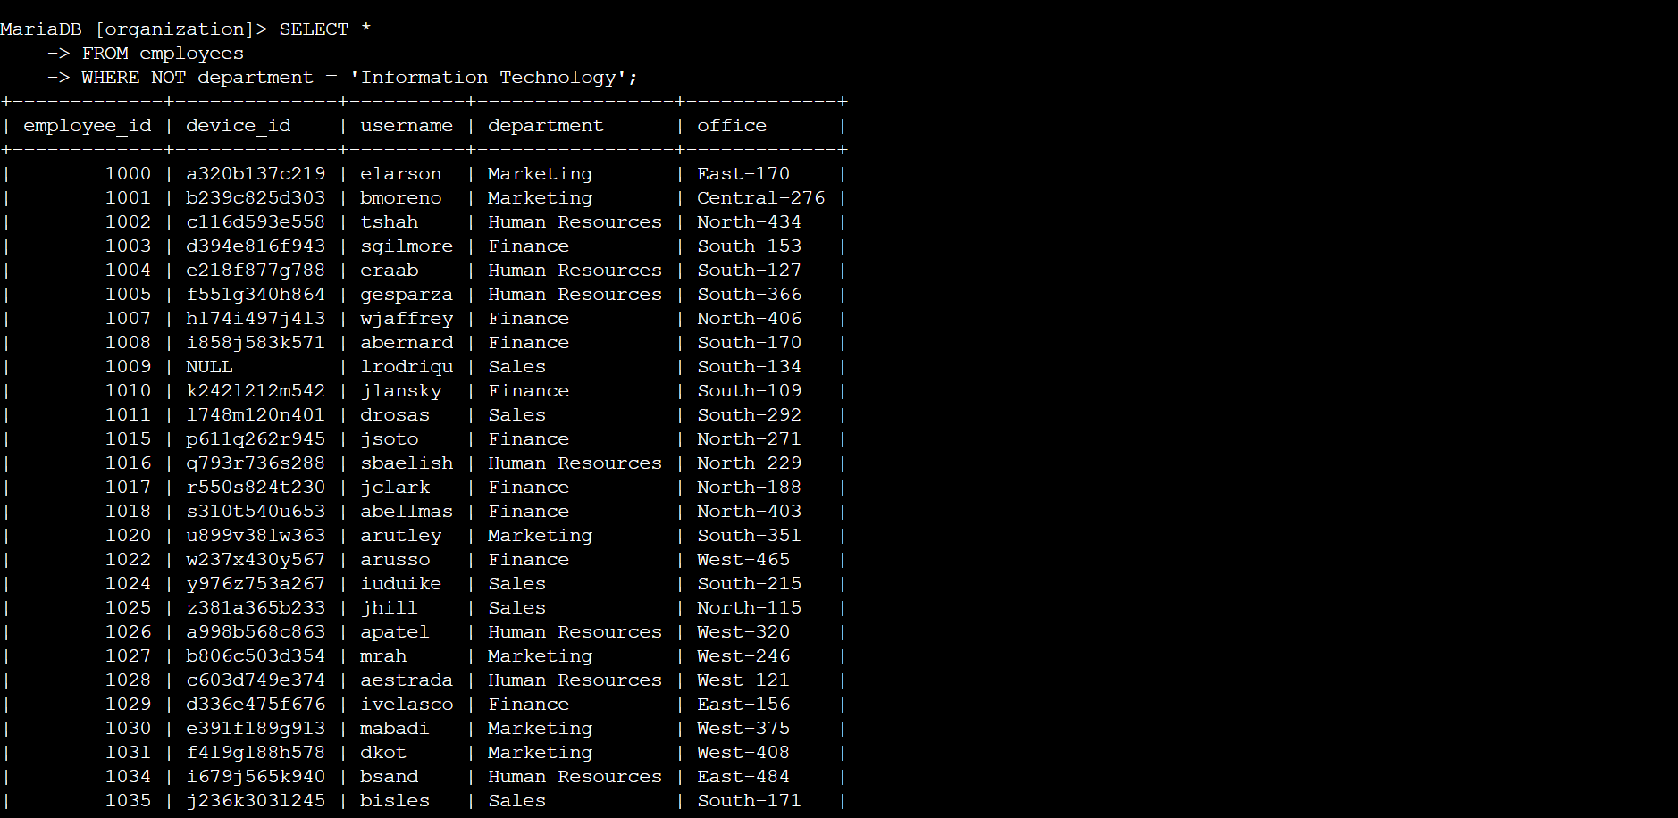

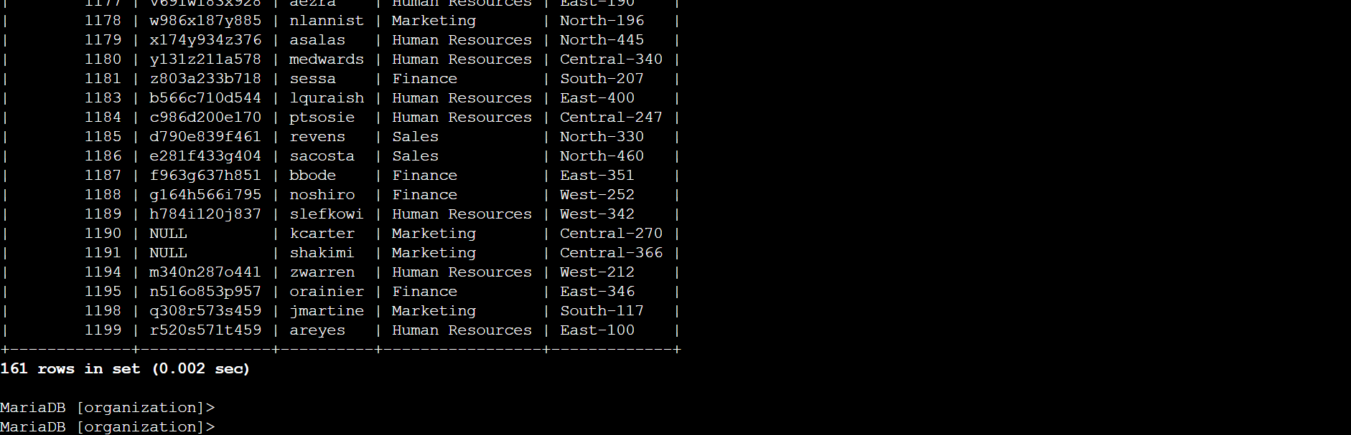

Summary
To Summarize I used Many SQL keywords such as AND, NOT, WHERE, LIKE and operators such as % to filter out data for my further investigation in the login attempts database. I used specific date and times to narrow down the most attacks that happened and where they happened. By doing this I found the suspicious activities in the attacks were mostly from outside “MEXICO” region. Then I needed to perform some security updates on specific employees of specific departments to further secure the system. I used queries to quickly list out the employees Who’s devices needed the updates.

